

pIWIK PRO SHAREPOINT analytics – INSTALLATION

Version 4.0.1

Contents

1. Introduction 2

1.1. Purpose of this document 3

1.2. Prerequisites 3

2. Install Piwik PRO components in SharePoint 4

2.1. Provision SharePoint components 4

2.2. Configure and activate Piwik PRO connector 6

|  |  |  |  |
| --- | --- | --- | --- |
| **Date** | **Version** | **Author** | **Description** |
| 07.05.2020 | 1.0 | P. Hawrylak | Document creation |
| 14.01.2022 | 4.0.1 |  |  |
|  |  |  |  |
|  |  |  |  |
|  |  |  |  |

# Introduction

## Purpose of this document

The document describes how to install Piwik PRO resources in Azure and SharePoint.

## Prerequisites

Before proceeding further please ensure that you have access to account or accounts with following permissions/roles:

* SharePoint Admin
* Contributor role to Azure subscription or to existing Resource Group in Azure
* Azure AD Global Administrator (or at least Application Developer role in Azure AD to create application registrations – this will require granting consent by global administrator manually).
* Access to Sharepoint global app catalog and possibility to upload SPFx package and Tenant Wide Extensions

PowerShell modules and command line interfaces:

* PnP PowerShell 3.23.2007.1+: <https://docs.microsoft.com/en-us/powershell/sharepoint/sharepoint-pnp/sharepoint-pnp-cmdlets>
* Azure CLI 2.9.1+: <https://docs.microsoft.com/en-us/cli/azure/install-azure-cli>

If these modules are not installed, they will be installed automatically by deployment scripts.

There is a possibility to install without permissions to global app catalog but with use site collection app catalog. This is **non standard** installation also without Azure step. It is recommended if:

* Only one site collection need to be tracked,
* There is no access to tenant app catalog,
* There is no possibility to install WebJob on Azure,

But it’s required also:

* manual creation of PiwikAdmin site collection with STS#3 template and url <https://[your-tenant].sharepoint.com/sites/PiwikAdmin>
* set property NoScript on false on both: PiwikAdmin and site collection for tracking,
* manual creation of App in Piwik PRO Analytics with enabled Sharepoint reports and uploaded tags by Piwik PRO support and get the GUID of this app.

# Install Piwik PRO components in SharePoint

## Provision SharePoint components

1. To provision SharePoint components, run Windows PowerShell as administrator in the context of the SharePoint folder in the installation directory.
2. Run Provision-ToSharePoint.ps1 script and provide correct parameters, e.g.:

*.\Provision-ToSharePoint.ps1*

1. On first step will be loaded UI to configure the variables.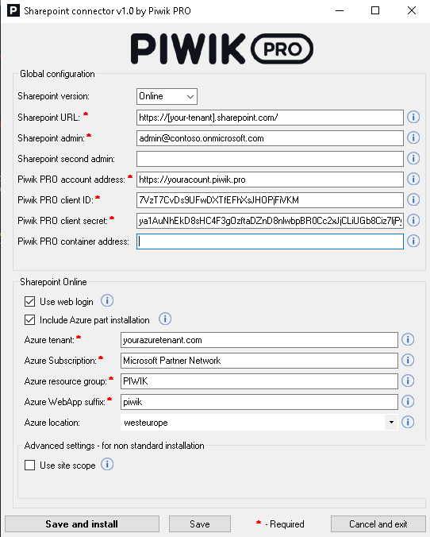

**Variables**:

* Sharepoint version: version of your installed Sharepoint server – in this case Online,

Sharepoint URL: Your SharePoint account address. Example: https://example.sharepoint.com.

* Sharepoint admin: A global admin account on your SharePoint tenant.
* Example: admin@contoso.onmicrosoft.com
* Sharepoint second admin: Optional - secondary admin account, will be added to sitecollection administrators in newly created PiwikAdmin site.

This admin will be able to access the form of configuration Piwik PRO Sharepoint connector.

Example: admin2@contoso.onmicrosoft.com

* Piwik PRO account address: The address you use to log in to Piwik PRO. Example: <https://yourname.piwik.pro>
* Piwik PRO client ID: A part of your API credentials. You can create it in Menu > Profile > API credentials. [Where to find it?](https://help.piwik.pro/support/questions/generate-api-credentials/)
* Piwik PRO client secret: A part of your API credentials. You can create it in Menu > Profile > API credentials. [Where to find it?](https://help.piwik.pro/support/questions/generate-api-credentials/)
* Piwik PRO container address: Optional (only for non-standard installation) - Enter your Piwik PRO account address with containers added to the address.

For standard domains: https://yourname.containers.piwik.pro

For custom domains: https://yourname.piwik.pro/containers

This address may be different for Piwik PRO on-premises or private cloud accounts. Contact us to get the right address.

* Use web login: select only if Multi Factor Authentication is turned on for your account.
* Include Azure part installation: For a standard installation, keep this option enabled. We'll install the WebJob on your Azure tenant. The WebJob connects Piwik PRO to SharePoint and registers new site collections that can be tracked.

If this option is disabled, you'll need to register new site collections manually in Piwik PRO.

* Azure tenant: Azure tenant name or resource group ID.
* Azure Subscription: Azure subscription name or resource group ID.
* Azure resource group: The name of a new or existing resource group.
* Azure WebApp suffix: A suffix added to the web app name. Example: piwikpro<webAppSuffix>.
* The suffix needs to be globally unique in Microsoft Azure. You can use your company’s name. You can use letters and numbers.
* Azure location: By default, the resource group is created in the West Europe region or inherits the existing location.

You can use a custom location. Example: westeurope, uswest.

For **non standard** installation:

* Use site scope: If checked, the SPFx package will be installed in the site collection app catalog (not in the tenant app catalog) and available only for the site collection specified in SharePointUrl. More information about it you can find in point 1.2 Prerequisites.

1. Script will ask for SharePoint credentials and should create Piwik PRO Administration site and deploy SPFx solution without any error.
2. In case of installation without Azure part and use Piwik PRO Sites Activator tool please leave the points below.
3. During the Azure part installation (if selected), on first you will be asked to login by Office365 Sharepoint tenant account (for configure app registrations, generate certificate), later asked to login by Azure account (to deploy WebJob).
4. If the installation will be finished please ensure that Global admin consent has been granted correctly. Please go to portal.azure.com > login as Sharepoint tenant admin account > Go to App Registrations > Select the new one with “piwik” in the name > go to API permissions and check:

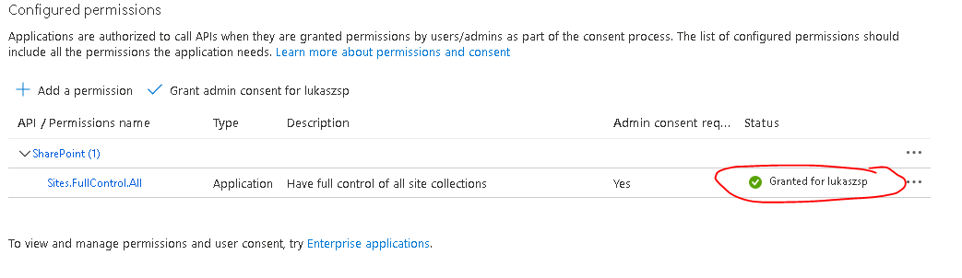

If there will be yellow icon in Status then you need to select this row and click “Grant admin consent for…”

## Configure and activate Piwik PRO connector

To turn on tracking for a site collection in SharePoint, follow these steps:

1. Log in to **SharePoint**.
2. Navigate to the site collection where you want to activate installed Piwik PRO connector.
3. Click on the settings wheel in the menu bar.
4. Choose **Piwik PRO settings**.  
   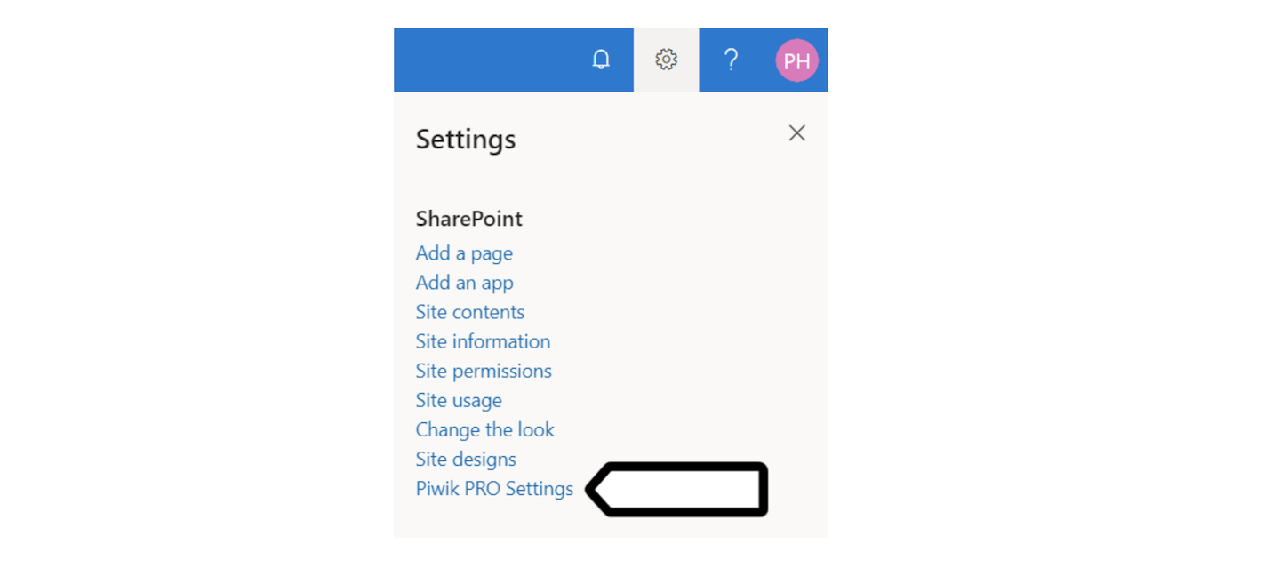
5. In **Site collection settings**, check **Enable tracking**.  
   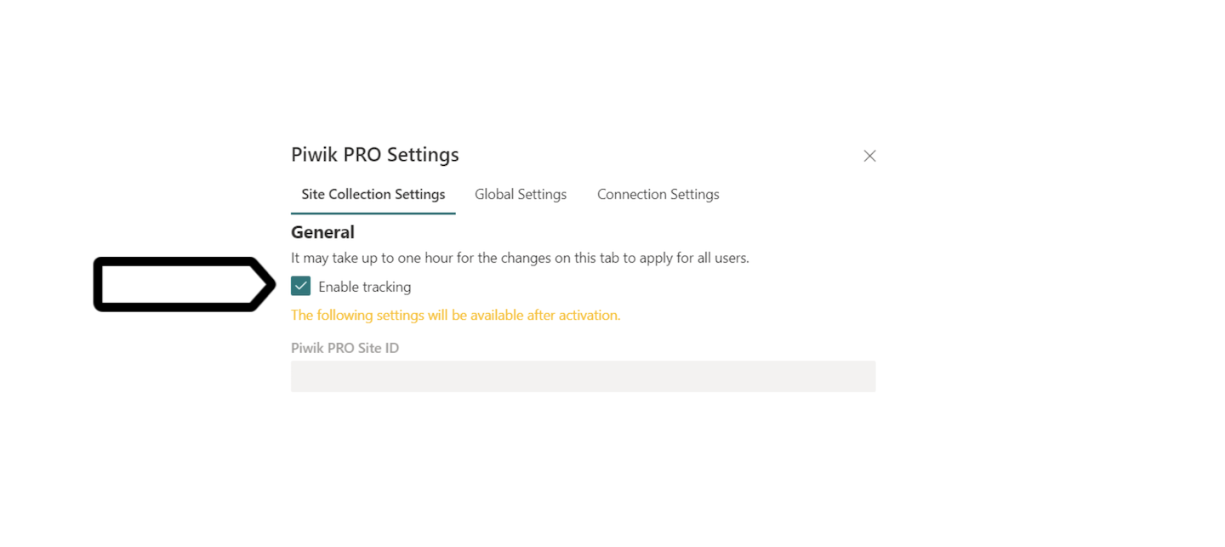

**Note:** If you installed Azure part it may take up to 10 minutes because there is an Azure WebJob which needs to be executed. In case of installation without Azure and use manual Piwik PRO Sites Activator tool please wait some minutes till the site will be crawled by the search and then run the tool.

1. This point is only for installation which using manual **Piwik PRO Sites Activator** tool for register and activate tracking on the site collections (if you are using Azure WebJob please leave this point).
   1. After select “Enable tracking” inside the Piwik PRO settings form and click on “Submit” button you need to wait some minutes for index the page by the search crawl.
   2. Go to the folder with application **PiwikPROSitesActivator.exe** and execute it.
   3. In first run of the tool you need to put url to your SharePoint root site and press enter:



**Note:** In another execution of tool the site url will be saved and you need to just press “Y” key to continue.

* 1. There will be opened a window for ask you the credentials for SharePoint site if there is a Multi Factor Authentication.
  2. The tool will use the search to check if there is any site collection for register or unregister in Piwik PRO Analytics.

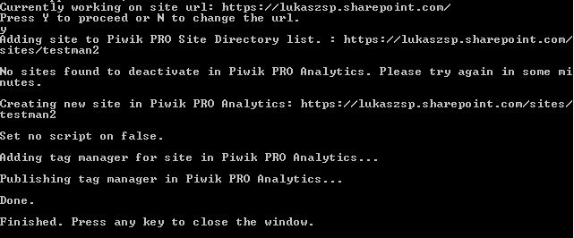

* 1. If there is a site collection which you just enabled the tracking then will be created and configured inside the Piwik PRO Analytics.

**Note:** This application needs to be executed every time after you made a change of enable or disable tracking in any SharePoint site collection.

* 1. In the case if the site has been activated or deactivated in Piwik PRO settings form and after much time still will be not visible in Activator console application then you can reset search indexes in the affected site collection (there is a manual how to do it: <https://docs.microsoft.com/en-us/sharepoint/crawl-site-content>)
  2. In special cases if the search is disabled or not working well you can put the name and url to the site collections in txt files inside the Piwik PRO Activator folder (Exceptional_SitesToManualActivation.txt – for manual activation of site collections and Exceptional_SitesToManualActivation for manual deactivation).

In the specific format (Title;Url) like:

SiteToActivate;https://contoso.sharepoint.com/sites/SiteToActivate/

Then if you run the Piwik PRO Activator application on first will take the site urls from those txt files instead of SharePoint search.

1. You can also check the tracking status on SharePoint’s administration site: **<your SharePoint URL>/sites/PiwikAdmin** > **Site contents** > **Piwik PRO site directory**.  
   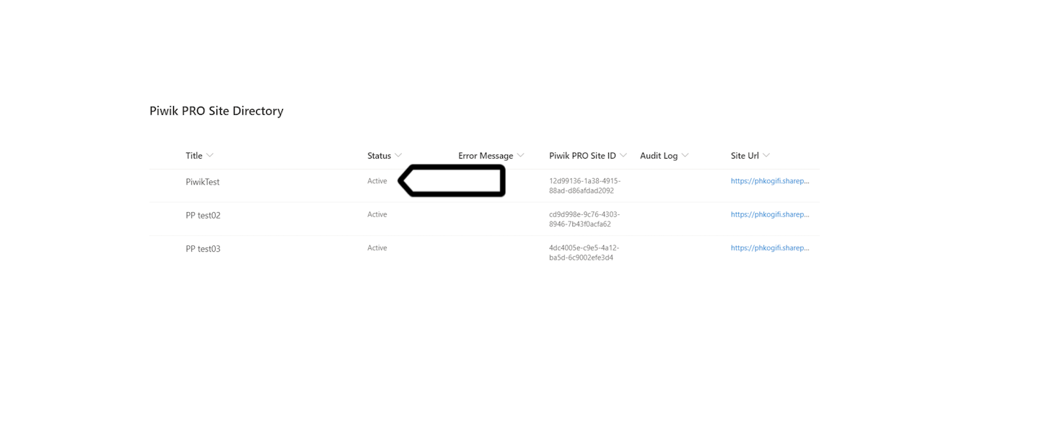

**Note:** Active means that Piwik PRO tracks the site collection. The tracked site collection will be automatically added as a new site to Piwik PRO.

**Important!** Piwik PRO variables inside site collection are stored in cache for one hour, so if the site is Active for tracking then after one hour or clearing cache manually the tracking will be started.

1. in **User information** inside the Piwik PRO settings form, you can choose to anonymize user IDs and collect additional data:  
   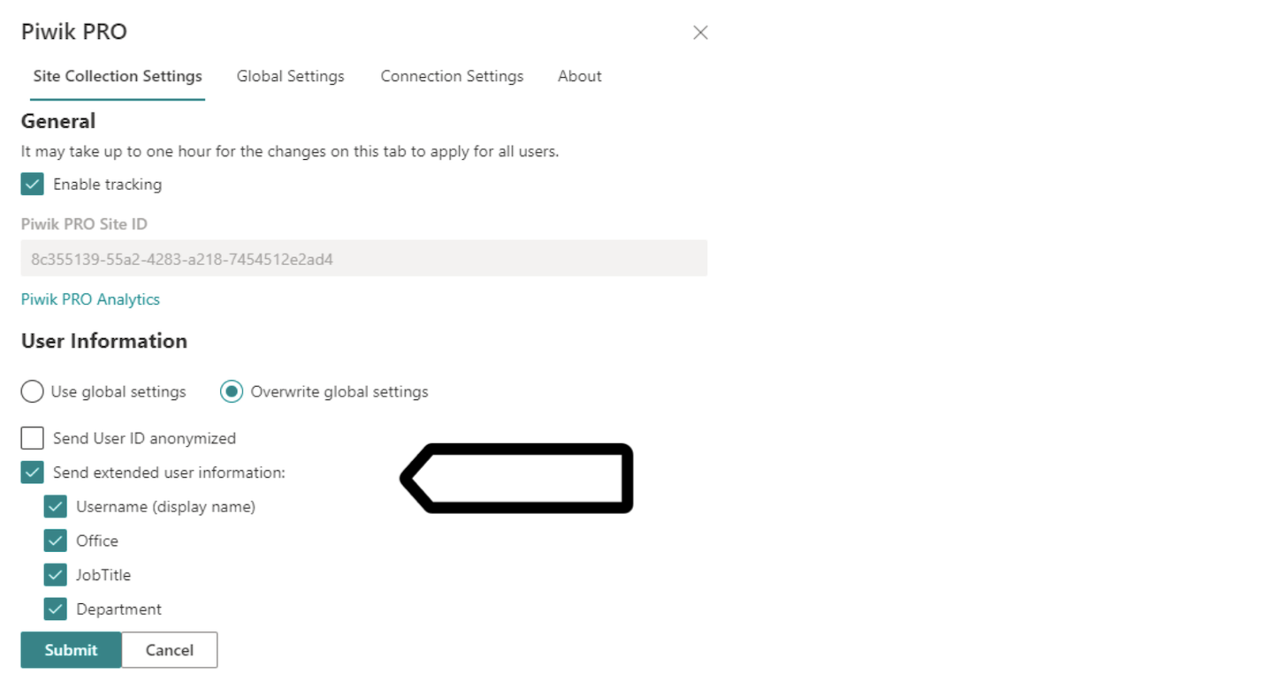

**Send User ID anonymized:** Users will still be recognized, but we’ll hide their ID.

**Send extended user information:** Check if you want to collect additional user data as custom dimensions in Piwik PRO Analytics:

- Username (display name)  
- Office  
- JobTitle  
- Department

8. You can also change settings for all sites at once in **Global Settings**.

